|  |  |
| --- | --- |
| Activity | Data Type |
| Number of beatings from Wife | Discrete |
| Results of rolling a dice | Discrete |
| Weight of a person | Continuous |
| Weight of Gold | Continuous |
| Distance between two places | Continuous |
| Length of a leaf | Continuous |
| Dog's weight | Continuous |
| Blue Color | Discrete |
| Number of kids | Discrete |
| Number of tickets in Indian railways | Discrete |
| Number of times married | Discrete |
| Gender (Male or Female) | Discrete |

Q1) Identify the Data type for the Following:

Q2) Identify the Data types, which were among the following

Nominal, Ordinal, Interval, Ratio.

|  |  |
| --- | --- |
| Data | Data Type |
| Gender | Nominal |
| High School Class Ranking | Ordinal |
| Celsius Temperature | Interval |
| Weight | Ratio |
| Hair Color | Nominal |
| Socioeconomic Status | Ordinal |
| Fahrenheit Temperature | Interval |
| Height | Ratio |
| Type of living accommodation | Nominal |
| Level of Agreement | Ordinal |
| IQ(Intelligence Scale) | Interval |
| Sales Figures | Ratio |
| Blood Group | Nominal |
| Time Of Day | Ordinal |
| Time on a Clock with Hands | Interval |
| Number of Children | Ratio |
| Religious Preference | Nominal |
| Barometer Pressure | Ordinal |
| SAT Scores | Interval |
| Years of Education | Ratio |

Q3) Three Coins are tossed, find the probability that two heads and one tail are obtained?

Let X be the possibilities of tossing a coin.

X = {HHH,TTT,HHT,HTH,THH,TTH,THT,HTT}

N(X) = 8

2H & 1T = 3

Probability = 3/8

Q4) Two Dice are rolled, find the probability that sum is

1. Equal to 1
2. Less than or equal to 4
3. Sum is divisible by 2and 3

X = {(1,1),(1,2),(1,3),(1,4),(1,5),(1,6),

(2,1),(2,2),(2,3),(2,4),(2,5),(2,6),

(3,1),(3,2),(3,3),(3,4),(3,5),(3,6),

(4,1),(4,2),(4,3),(4,4),(4,5),(4,6),

(5,1),(5,2),(5,3),(5,4),(5,5),(5,6),

(6,1),(6,2),(6,3),(6,4),(6,5),(6,6)}

N(X) = 36

1. Sum is equal to 1 = 0/36
2. <=4 = 6/36 = 1/6
3. Sum is divisible by 2&3 = 6/36 = 1/6

Q5) A bag contains 2 red, 3 green and 2 blue balls. Two balls are drawn at random. What is the probability that none of the balls drawn is blue?

2 balls drawn at random = {RR,GG,BB,RG,RB,GR,GB,BR,BG}

Probability (none of the balls drawn is blue) = 4/9

Q6) Calculate the Expected number of candies for a randomly selected child

Below are the probabilities of count of candies for children(ignoring the nature of the child-Generalized view)

|  |  |  |
| --- | --- | --- |
| CHILD | Candies count | Probability |
| A | 1 | 0.015 |
| B | 4 | 0.20 |
| C | 3 | 0.65 |
| D | 5 | 0.005 |
| E | 6 | 0.01 |
| F | 2 | 0.120 |

Child A – probability of having 1 candy = 0.015.

Child B – probability of having 4 candies = 0.20

Expected number of candies for a randomly selected child is:

(1*0.015)+(4*0.20)+(3*0.65)+(5*0.005)+(6*0.01)+(2*0.120)

= 0.015+0.8+1.95+0.025+0.06+0.24

=3.09

Q7) Calculate Mean, Median, Mode, Variance, Standard Deviation, Range & comment about the values / draw inferences, for the given dataset

* For Points,Score,Weigh>

Find Mean, Median, Mode, Variance, Standard Deviation, and Range and also Comment about the values/ Draw some inferences.

**Use Q7.csv file**

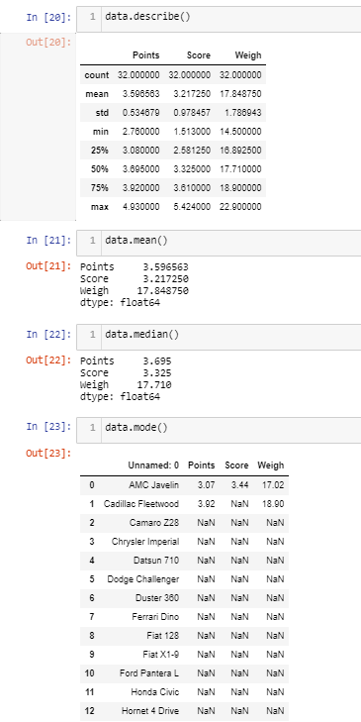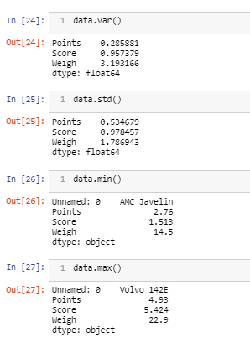

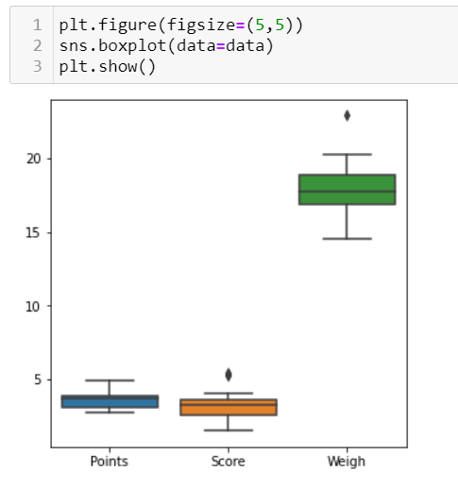

Q8) Calculate Expected Value for the problem below

1. The weights (X) of patients at a clinic (in pounds), are

108, 110, 123, 134, 135, 145, 167, 187, 199

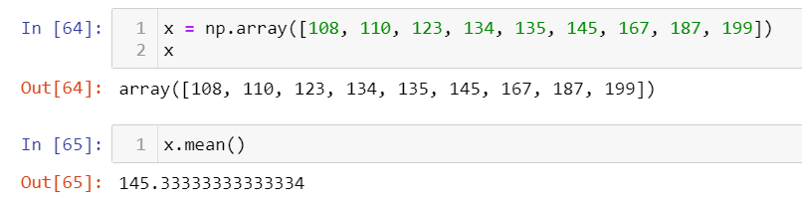Assume one of the patients is chosen at random. What is the Expected Value of the Weight of that patient?

**Q9) Calculate Skewness, Kurtosis & draw inferences on the following data**

**Cars speed and distance**

**Use Q9_a.csv**

**SP and Weight(WT)**

**Use Q9_b.csv**

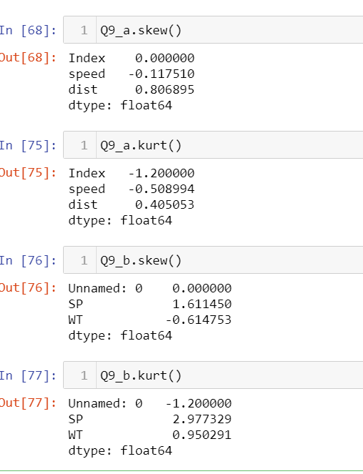

**Q10) Draw inferences about the following boxplot & histogram**



Findings from Histogram:

It talks about the chicken weight. The high number of chicken weight is between 50 to 100. And the count gradually decreases as the chicken weight decreases.

Findings from Boxplot:

From the boxplot, could see there are outliers at the top.

**Q11)**Suppose we want to estimate the average weight of an adult male in Mexico. We draw a random sample of 2,000 men from a population of 3,000,000 men and weigh them. We find that the average person in our sample weighs 200 pounds, and the standard deviation of the sample is 30 pounds. Calculate 94%,98%,96% confidence interval?

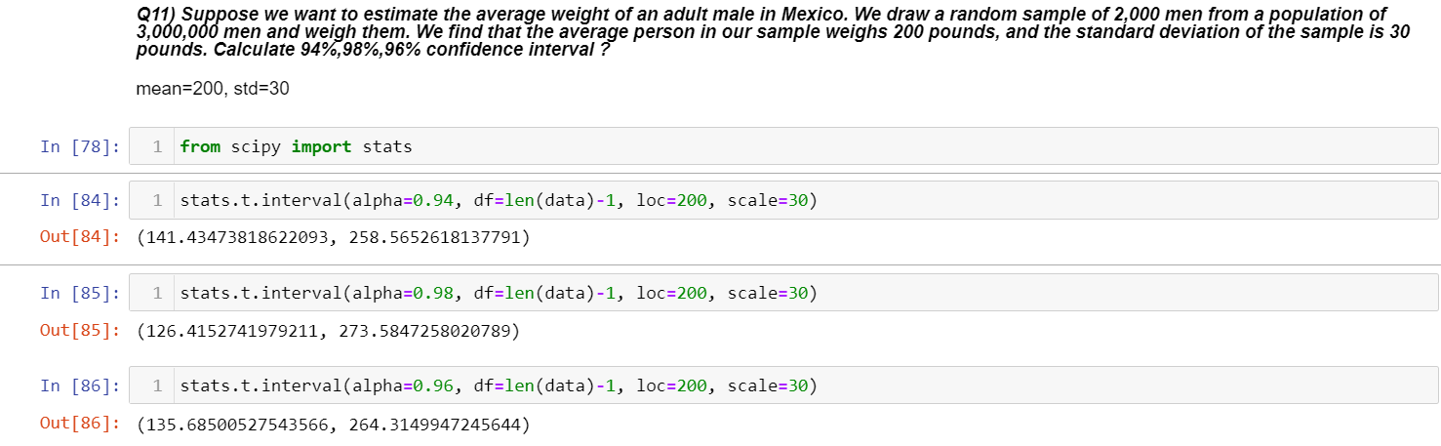

**Q12)**Below are the scores obtained by a student in tests

**34,36,36,38,38,39,39,40,40,41,41,41,41,42,42,45,49,56**

1. Find mean,median,variance,standard deviation.

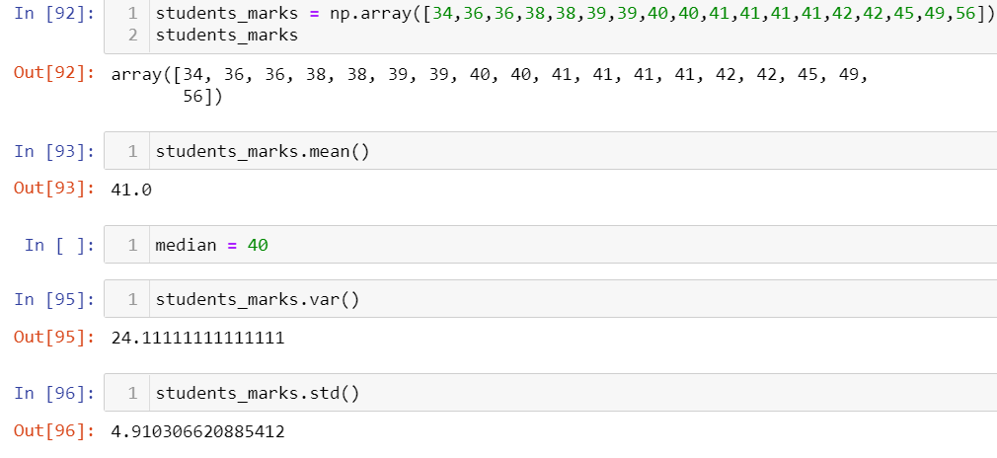

1. What can we say about the student marks?

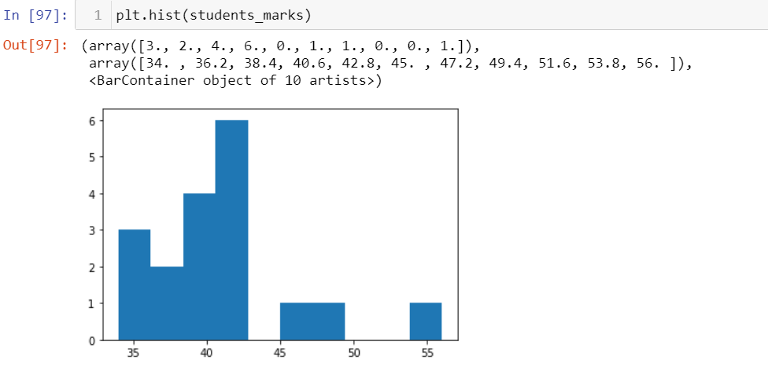

From the histogram, high students have got around 40 marks. And the graph is not normally distributed.

Q13) What is the nature of skewness when mean, median of data are equal?

Data will be equally distributed and will be normalized. Skewness will not be there when mean=median=mode.

Q14) What is the nature of skewness when mean >median ?

When mean>median, large amount of data will be available in right side leading to negative skewness.

Q15) What is the nature of skewness when median > mean?

When median>mean, large amount of data will be available in left side leading to positive skewness.

Q16) What does positive kurtosis value indicates for a data ?

It indicates thin peak and wide tails

Q17) What does negative kurtosis value indicates for a data?

It indicates thin tails and wide peak

Q18) Answer the below questions using the below boxplot visualization.



What can we say about the distribution of the data?

Distribution is not normal.

What is nature of skewness of the data?

Negative skewness as data is in right side

What will be the IQR of the data (approximately)?   
ranging between 10 to 18  
  
  
Q19) Comment on the below Boxplot visualizations?



Draw an Inference from the distribution of data for Boxplot 1 with respect Boxplot 2.

Boxplot 1 has less range than boxplot2.

Q 20) Calculate probability from the given dataset for the below cases

Data _set: Cars.csv

Calculate the probability of MPG ofCars for the below cases.

MPG<- Cars$MPG

* 1. P(MPG>38)
  2. 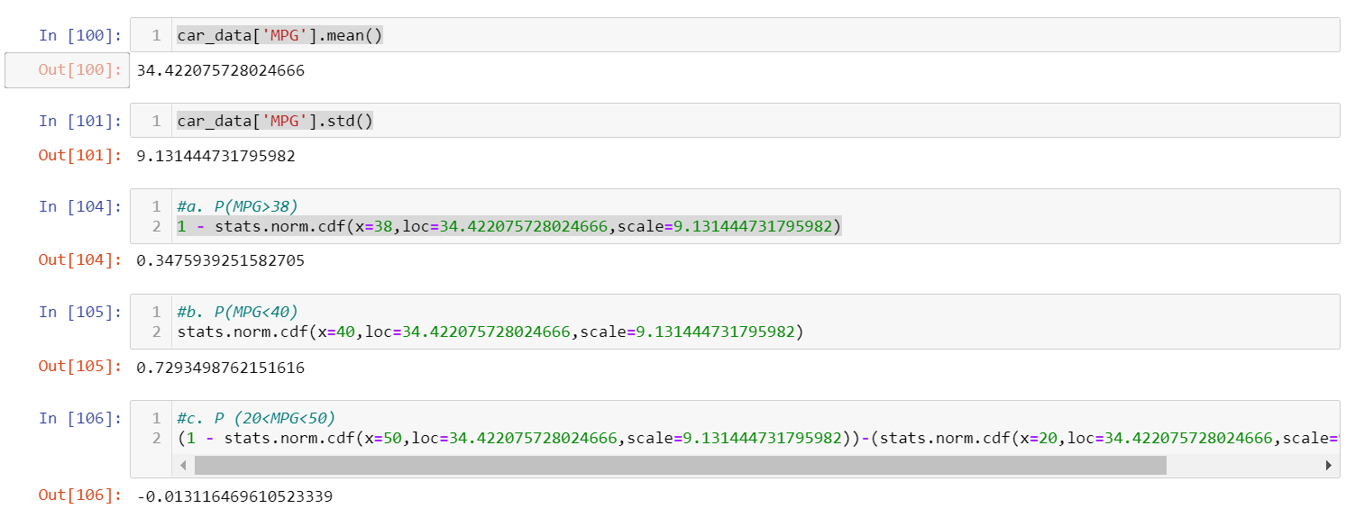P(MPG<40)
  3. P (20<MPG<50)

Q 21) Check whether the data follows normal distribution

1. Check whether the MPG of Cars follows Normal Distribution

Dataset: Cars.csv

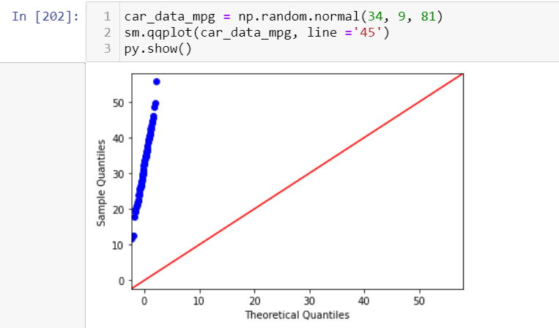

It is not normally distributed

1. Check Whether the Adipose Tissue (AT) and Waist Circumference(Waist) from wc-at data set follows Normal Distribution

Dataset: wc-at.csv

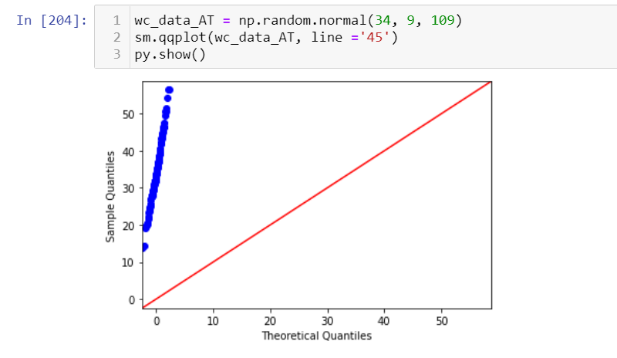

It is not normally distributed

Q 22) Calculate the Z scoresof 90% confidence interval,94% confidence interval, 60% confidence interval

From manual calculation,

Z-score of 90% confidence interval = 0.84

Z-score of 94% confidence interval = 1.65

Z-score of 60% confidence interval = 1.88

Q 23) Calculate the t scores of 95% confidence interval, 96% confidence interval, 99% confidence interval for sample size of 25

t-score of 95% confidence interval = 2.06

t-score of 96% confidence interval = 2.18

t-score of 99% confidence interval = 2.8

Q 24**)**A Government companyclaims that an average light bulb lasts 270 days. A researcher randomly selects 18 bulbs for testing. The sampled bulbs last an average of 260 days, with a standard deviation of 90 days. If the CEO's claim were true, what is the probability that 18 randomly selected bulbs would have an average life of no more than 260 days

Hint:

rcode🡪pt(tscore,df)

df 🡪 degrees of freedom

**Solution:**

x = mean of the sample of bulbs =  260

μ = population mean = 270

s = standard deviation of the sample = 90

n = number of items in the sample = 18

t = - 0.471

For probability calculations, the number of degrees of freedom is n - 1, so here you need the t-distribution with 17 degrees of freedom.

The probability that **t < - 0.471 with 17 degrees of freedom** assuming the population mean is true, the t-value is less than the t-value obtained With 17 degrees of freedom and a t score of - 0.471, the probability of the bulbs lasting less than 260 days on average of **0.3218** assuming the mean life of the bulbs is 300 days.